ICL-1302 Computer Systems

TOBY BEEVERS

*Cambria ID: 21075206 Bangor ID: 500704883*

APPLIED DATA SCIENCE DEGREE APPRENTICESHIP BSC

Contents

Abstract 2

History 2

Computers Today 2

Computers of Tomorrow 2

Motherboard 3

Chipset 3

Processor (CPU) 3

Who makes CPU’s? 3

Power supply 4

We need to be smarter with energy consumption. 4

Memory (RAM) 4

Permanent storage (HDD or SSD) 4

Hard Disc Drives 5

Solid State Drives 5

Benefits & Risks 5

Network interface 6

Graphics interface 6

GPU History 6

Today’s World of GPUs 7

Practical Lab Session 7

8

References 9

# Abstract

For this exercise I have attempted to answer the question “*What is a computer*?” A computer isn’t just a box that sits on your desk to send email, a computer is an electronic device that manipulates information.

### History

It could be argued that the first devices to compute numbers where establish thousands of years go in the form of an abacus, however, computers as we know them today had to wait until we better understood binary and the base two number systems.

Charles Babbage is widely considered the *Father of Computing* for his work on the first mechanical computer in the early 19th century, later followed by mathematician Alan Turing and his 1936 publication *On Computable Numbers* *(Wikipedia.Org, 2023)*.

The 1950’s saw the introduction of Main Frame Computers; these are closer to what we consider a computer today, but it was well into the 1970’s before Desktop Computers became a common sight in offices *(Wikipedia.Org, 2023)*.

### Computers Today

Fast forward 50 years and computers are everywhere, in our doorbells and fridges, cars, we even have computers on our wrists.

Today computers are everywhere, we depend on them for almost everything in our daily lives. The latest emergences are referred to as the Internet of Things (IoT), these devices are sensor or software that connect directly to the internet and stream millions of pieces of data every second. By 2030 McKinsey & Co. estimate that the IoT industry will be worth somewhere in the region of $12.5 trillion *(Mckinsey & Company, 2022)*.

### Computers of Tomorrow

As science leaps forward, we see innovative technologies like quantum computing, in 2021 Shenzhen SpinQ Technology announced the release the world first desktop quantum computer.

Other technologies are also emerging in the form of Chemical, Optical, DNA, and Neural computing, along with the increased accessibility of Artificial Intelligence (AI) the next generation of computers are set to change the world of today.

# Motherboard

*noun: motherboard; plural noun: motherboards; noun: mainboard; plural noun: mainboards.*

*A printed circuit board containing the principal components of a computer or other device, with connectors for other circuit boards to be slotted into* (Cambridge Advanced Learner's Dictionary & Thesaurus Cambridge University Press, 2023)*.*

A Motherboard, sometimes known as the Central Processor is one of the most important parts of a computer, the Motherboard brings all the other components together and allows them to communicate with each other.

*Image Credit: Wikipedia*

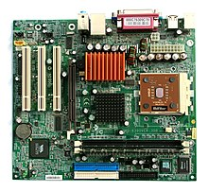

A printed circuit board, the Motherboard is often secured to the computer case and is made up of multiple sockets to support the connection of other peripherals like the RAM, CPU and GPU.

### Chipset

One of the main components of the Mother Board is the Chipset. The Chipset allows communication between the CPU, Memory, storage, and other peripherals, supporting the efficient transfer of data.

Pre 2000’s Motherboard architecture would have included separate North and South Bridges, however manufacturers like Intel and AMD have favoured a move towards combining these into a single Chipset (Hameed, 2019)(D, 2023).

(Wikipedia.Org, 2023)

# Processor (CPU)

CPU or Central Processing Unit is a primary component, acting like the brain or control centre, the CPU is responsible for running the computers Operating System and performs logic and arithmetic, as well as interpreting, processing, and executing instructions.

CPU’s have Cores which execute Threads, the more Threads a Core can process the better the speed and efficiency of multitasking (Walilko, 2023)*.*

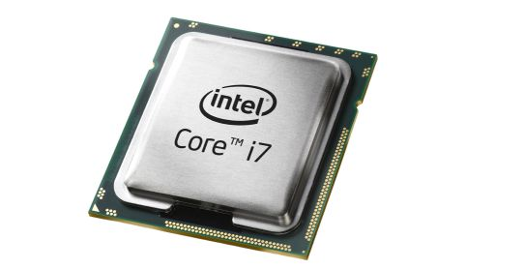

*Image Credit: maelfabien.github.io*

### Who makes CPU’s?

The main manufacturers of CPUs are Intel and AMD. Intel use their own x86 architecture, whilst AMD is a licensee of ARM who are a UK based CPU design company, many other smaller CPU manufacturers are also licensed under the ARM design.

# Power supply

A desktop PC like most other electronic devices uses Direct Current (DC), the job of the Power Supply, also known as the Power Supply Unit (PSU) is to convert alternating current (AC) into DC.

*Image Credit: minitool.com*

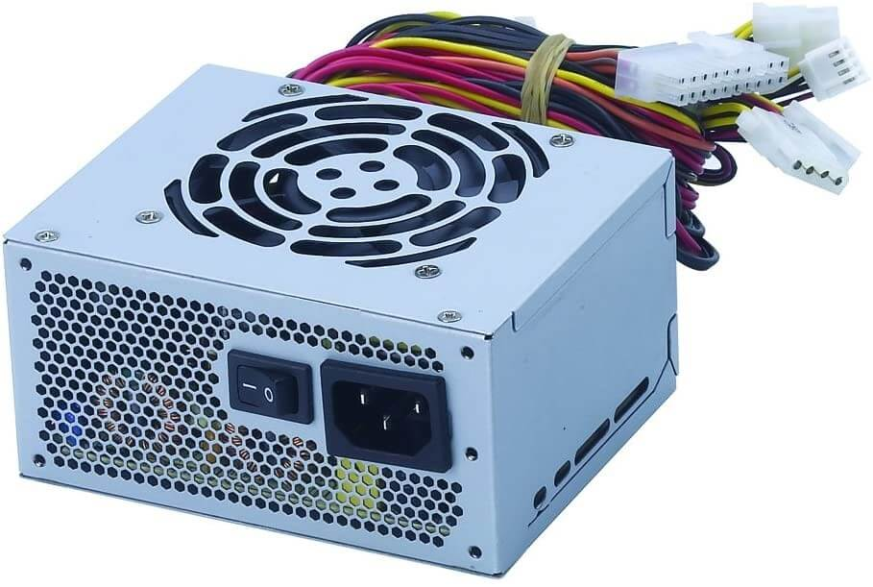

Another important feature of the PSU is its ability to provide a standby feature that provides a low 5v supply, a standby feature is important to allow certain peripherals to remain connected.

Power is the fundamental part of any computing, figures from 2019 suggest that over 1.3 billion people now own a personal computer. With the average computer uses about 746kw per year, the race is on to understand how designers can make PSUs more power efficient to help reduce the impact on carbon emissions (Wikipedia.org, 2023).

### We need to be smarter with energy consumption.

In 2007 computer industry leaders combined forces with a common goal of promoting smart technologies that improve power efficiency and reduce energy consumption, they later combined with The Green Grid in 2012 (Wikipedia.Org, 2023)who goal is to create tools that optimise energy consumption.

*Mission Statement: The Green Grid works globally to create tools, provide technical expertise, and advocate for the optimization of energy and resource efficiency of Data Centre ecosystems which enables a low carbon economy* (The Green Grid, 2023).

# Memory (RAM)

Random-Access Memory (RAM) is a computers *short term* memory, this is where data is stored when your computer is running its applications, and opening files.

*Image Credit: Wikipedia*

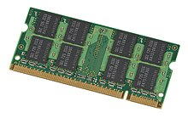

RAM speed is critical to the user experience, each time a user makes a request in a game or when streaming a video, the RAM is used to load data into the CPU to share with the Applications (Intel, 2023).

Most Motherboards have multiple RAM slots which allow for a pair of RAM cards, also known as Multi Channel RAM. Daul RAM is one type of multi-channel RAM, this helps to speed up the exchange of data with increased speeds. However, it’s important to understand that not all CPU’s can handle multi-channel RAM and consideration must be made for the CPUs memory controller (Crucial.com, 2023).

# Permanent storage (HDD or SSD)

Although still used, the term *Permanent Storage* is widely considered redundant unless considering RAM, the term refers to offering the ability to store data regardless of the of an available power source.

The term non-volatile has replace the term Permanent Storage and can be used when referring to HDD (Hard Dice Drives) or SSD (Solid State Drives), there is also Optical Storage in the form of Blue-Ray, DVD-R and DVD.

### Hard Disc Drives

HDD’s are an older technology that allows storage of large amounts of data, using an electromagnetic head to Read/Write data in Binary form with positive or negative charges.

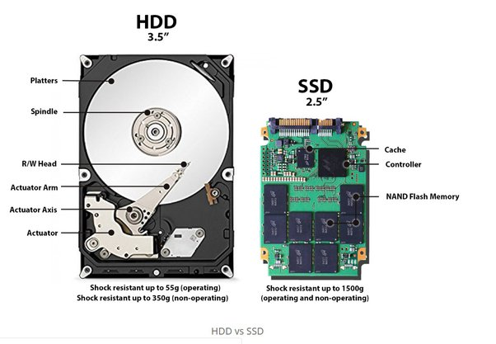

*Image Credit: quora.com*

The surface of the HDD is divided into circular tracks and sectors, splitting the surface of the HDD like this, provides physical addresses to remember where data is saved.

A PCB carefully co-ordinates a rotating disk and swinging access arm called the *Actuator* to allow the read/write head to access any location as quickly as possible.

### Solid State Drives

SDD’s operate fast than traditional HDD’s, however the cost of SSD’s is still considerably higher than HDD’s for the same amount of storage space.

SSD’s use something called NAND flash memories, these are thousands of tiny transistors wired in a series. NAND stands for NOT AND which refers to the Boolean Operators of the internal circuits, a NAND produces a False value if both inputs are TRUE (purestorage.com, 2023)*.*

SSD’s have the advantage of having no mechanical moving parts and therefore immediate access to the data, however, over time they can be prone to something called *Leakage*. Leakage is where NAND cells can no longer retain their charge and start leaking electrons, this can lead to situations where Writes and be Read back immediately but overtime data retention can be affected.

(Computer Science GCSE Guru, 2023)

### Benefits & Risks

|  |  |  |
| --- | --- | --- |
|  | **Benefits** | **Risks** |
| **Hard Disc Drive** | Can hold large amounts of data at affordable prices.  Reliable technology and relatively small. | Moving parts, will eventually wear out.  Less robust than a solid-state drive, can be fragile during transport.  Higher power consumption than an SSD, moving parts van be noisy. |
| **Solid State Drive** | Small physical size ideal for portable devices.  No moving parts to wear or get damaged.  Uses less power than an HDD, better battery life.  Very quiet, generates less heat. | More expensive to buy per GB.  Limited number of writes, can see also be susceptible to leakage overtime meaning they lose data. |

# Network interface

A Network Interface Controller (NIC) is a hardware component that supports a PC with connections to a Local Area Network (LAN).

The device itself is classified as Physical in the OSI model, however, the NIC works as part of Layer Two and is responsible for retaining the Media Access Control Address (MAC) and supports the transfer of the frames and data packets. You will also find references to the NIC at Layer 3 as it operates as an interface for the TCP and UDP protocols.

*Image Credit: uk.rs-online.com*

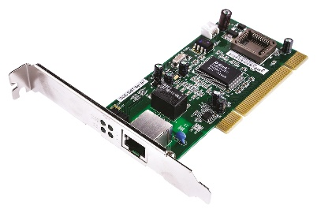

Today, there are many ways for devices to connect to our networks, you will find wireless connections, wired LAN connections, fibre optic and USB (Universal Serial Bus) *(Contributor, 2021).*

# Graphics interface

Graphics Cards, also known as GPU (Graphic Processing Unit), are a processing unit dedicated to processing the graphics that are required to run your computers applications.

*Image Credit: alamy.com*

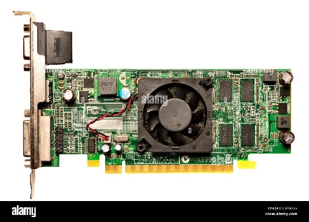

The image you see on your monitor is made of binary data, 0 and 1, the job of the GPU is to translate these into the rich pictures we’re used to today. The computers applications work with the CPU to provide the GPU with data, the GPU then translates this into pixels to create the image on the screen *(Tyson, et al., 2021)*.

### GPU History

There is a rich history when it comes to Graphics Cards, consider how quickly user demands have changed over the last 15 years, how much gaming has changed for example.

Back in the 1970’s and early 80’s there where standard like VGA (Video Graphics Array), and MDA (IBMs Monochrome Display Adapter), the graphics requirement where so much less than we see today, just lines of green text rendered on to the screen.

As we moved into the 1990’s along came the gaming revolution, video graphics become common in arcades, we saw the introduction of the Saga Mega Drive. During this decade there was a massive acceleration and by the turn of the century we had multiple gaming consoles like the Play Station and the Nintendo 64.

Fast forward to 2023 and we can now join video calls on platforms like Microsoft Teams where we get to see people on the other side of the world, a long way from lines of green text. Hello World! *(Wikipedia.Org, 2023)*.

### Today’s World of GPUs

*Image Credit: nvidia.com*

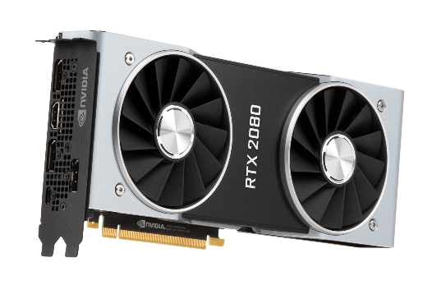

Today’s GPU market is one of the fastest growing segments in hardware, a 2022 market study suggested today’s value is somewhere in the region of $22,940M USD, and set to grow to $35,800M USD by 2028 (www.industryresearch.biz, 2023)*.*

# Practical Lab Session

During a session on Thursday 26th November 2023, the class established small groups with the target of dismantling and rebuilding a desktop computer. We had various difference levels within our group, some students had never seen inside a desktop computer, others had built their own desktop computer.

During the sessions, the more experienced members of the group oversaw the less experience members of the group and guided them through the processes of.

* Accessing the computer and removing the out case.
* Understanding where the RAM is located and how it attaches to the Motherboard.
* Locating the Central Processing Unit (CPU) on the Motherboard and removing the cooling systems to allow access to the CPU itself.
* Establishing the Storage Devices, in our case we had a Solid-State Drive (SSD).
* Detecting the Network Interface and seeing the connection to the Motherboard to understand how our PC connects to the Local Area Network (LAN).
* Pinpointing the Graphics Card (GPU), we had a discussion on the size of GPUs depending on the purpose of the machine.
* Understanding where the Power Supply is located, although we did not remove this.

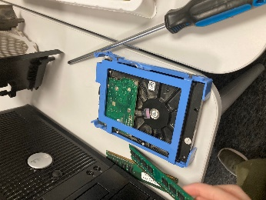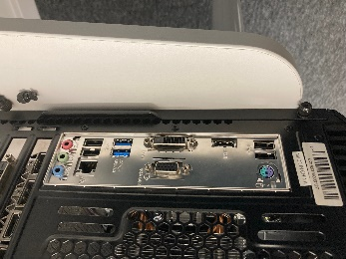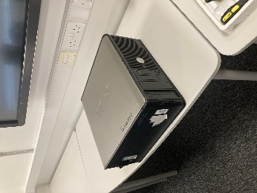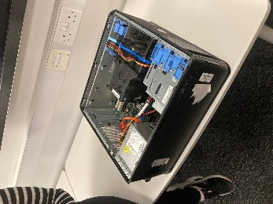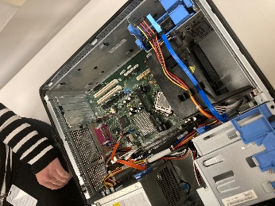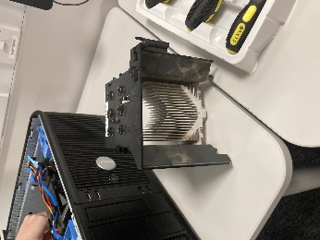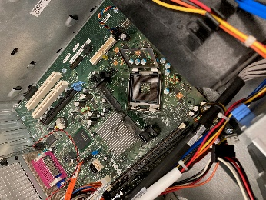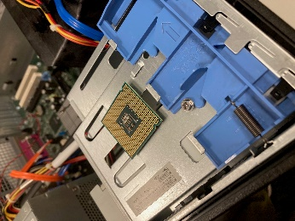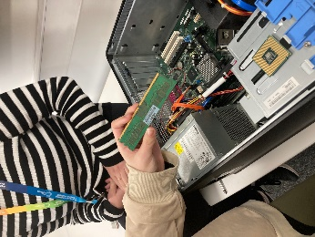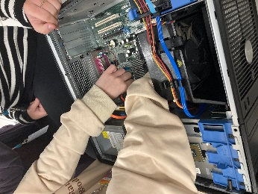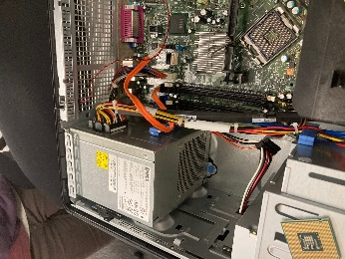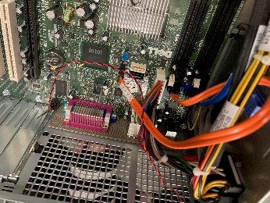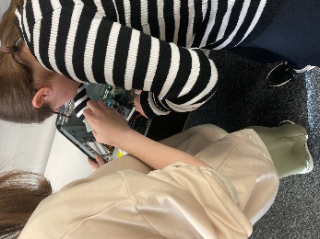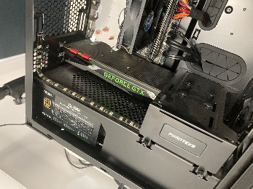

Then the Team rebuilt the Desktop and secured the case

# References

Cambridge Advanced Learner's Dictionary & Thesaurus Cambridge University Press, 2023. *Motherboard.* [Online]   
Available at: https://dictionary.cambridge.org/dictionary/english/motherboard  
[Accessed 28 10 2023].

Computer Science GCSE Guru, 2023. *Storage Devices.* [Online]   
Available at: https://www.computerscience.gcse.guru/theory/storage-devices  
[Accessed 02 11 2023].

Contributor, T., 2021. *Network interface card (NIC).* [Online]   
Available at: https://www.techtarget.com/searchnetworking/definition/network-interface-card  
[Accessed 5 11 2023].

Crucial.com, 2023. *What is Dual-Channel Memory?.* [Online]   
Available at: https://uk.crucial.com/articles/about-memory/what-is-dual-channel-memory#:~:text=Dual%2Dchannel%20RAM%20is%20one,memory%20and%20the%20memory%20controller.  
[Accessed 2 11 2023].

D, M., 2023. *What is a Motherboard Chipset? How It Impacts the Performance?.* [Online]   
Available at: https://www.electronicshub.org/what-is-a-motherboard-chipset/  
[Accessed 28 10 2023].

Hameed, T., 2019. *North and south bridges of a motherboard explained.* [Online]   
Available at: https://srgtech78.wordpress.com/2019/01/25/north-and-south-bridges-of-a-motherboard-explained/  
[Accessed 28 10 2023].

Intel, 2023. *What Is Computer and Laptop RAM?.* [Online]   
Available at: https://www.intel.com/content/www/us/en/tech-tips-and-tricks/computer-ram.html  
[Accessed 2 11 2023].

Mckinsey & Company, 2022. *What is the Internet of Things?.* [Online]   
Available at: https://www.mckinsey.com/featured-insights/mckinsey-explainers/what-is-the-internet-of-things  
[Accessed 28 10 2023].

purestorage.com, 2023. *What Is 3D NAND and How Does It Work?.* [Online]   
Available at: https://www.purestorage.com/knowledge/what-is-3d-nand.html#:~:text=What%20does%20NAND%20stand%20for,if%20both%20inputs%20are%20TRUE.  
[Accessed 2 11 2023].

The Green Grid, 2023. *About Us.* [Online]   
Available at: https://www.thegreengrid.org/en/about-us  
[Accessed 28 10 2023].

Tyson, j., Wilson, T. & Homer, T., 2021. *How Graphics Cards Work.* [Online]   
Available at: https://computer.howstuffworks.com/graphics-card.htm  
[Accessed 5 11 2023].

Walilko, A., 2023. *What Are CPU Cores vs Threads?.* [Online]   
Available at: https://www.liquidweb.com/blog/difference-cpu-cores-thread/#:~:text=A%20thread%20is%20a%20sequence,speed%20and%20efficiency%20of%20multitasking.  
[Accessed 28 10 2023].

Wikipedia.Org, 2023. *Climate Savers Computing Initiative.* [Online]   
Available at: https://en.wikipedia.org/wiki/Climate_Savers_Computing_Initiative  
[Accessed 28 10 2023].

Wikipedia.Org, 2023. *Computer.* [Online]   
Available at: https://en.wikipedia.org/wiki/Computer#History  
[Accessed 28 10 2023].

Wikipedia.Org, 2023. *Graphics card.* [Online]   
Available at: https://en.wikipedia.org/wiki/Graphics_card  
[Accessed 5 11 2023].

Wikipedia.Org, 2023. *Mainframe computer.* [Online]   
Available at: https://en.wikipedia.org/wiki/Mainframe_computer  
[Accessed 28 10 2023].

Wikipedia.Org, 2023. *Motherboard.* [Online]   
Available at: https://en.wikipedia.org/wiki/Motherboard#Bootstrapping  
[Accessed 28 10 2023].

Wikipedia.org, 2023. *Power supply unit (computer).* [Online]   
Available at: https://en.wikipedia.org/wiki/Power_supply_unit_(computer)#Efficiency  
[Accessed 28 10 2023].

www.industryresearch.biz, 2023. *Graphics Processing Unit (GPU) Market Insights 2023: Technological Advancements, and Regional Growth Strategies 2030.* [Online]   
Available at: https://www.linkedin.com/pulse/graphics-processing-unit-gpu-market-insights-2023#:~:text=Market%20Analysis%20and%20Insights%3A%20Global,7.7%25%20during%20the%20review%20period  
[Accessed 5 11 2023].